- Add groups boys and girls



- Create users guru, arun, rani , and selvi



- Add users guru and arun to the boys group

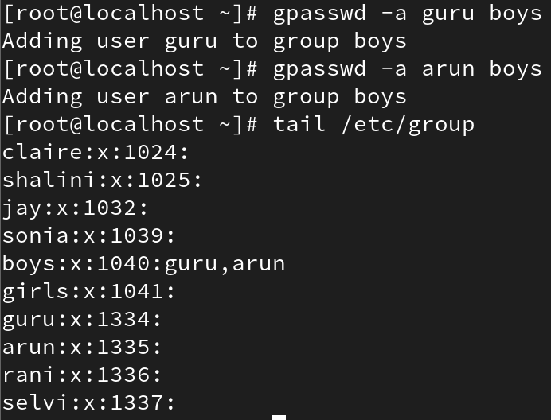

- Add users rani and selvi to the girls group

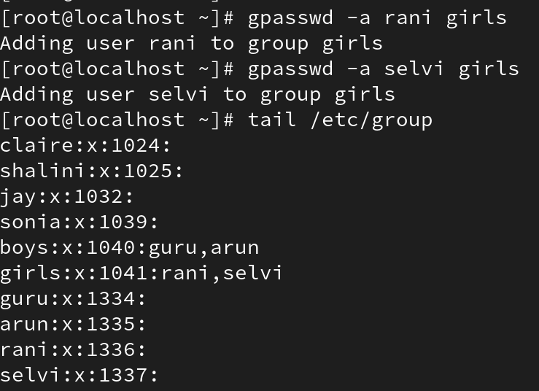

- Create the directory classroom in /.

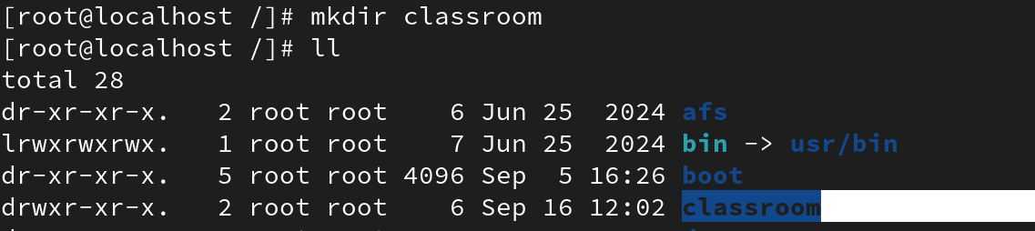

- Create directories kings and queens inside the classroom directory.

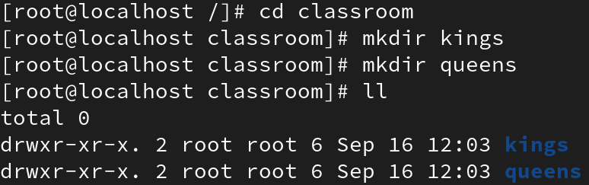

- Set full permissions for the boys group on the kings directory and full permissions for the girls group on the queens directory.

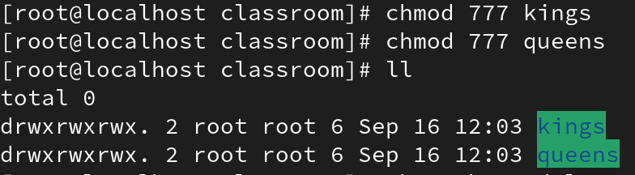

- Change the group ownership of the kings directory to boys and the queens directory to girls.

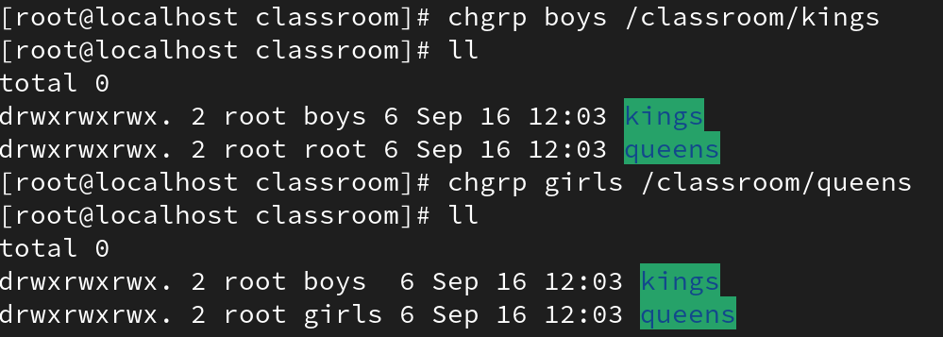

- Remove all permissions for others from both the kings and queens directories.

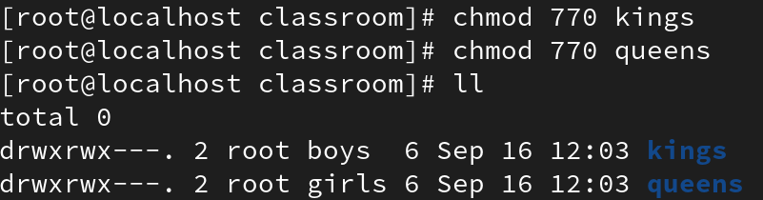

Now, only members of the boys group will have access to the kings directory, and only members of the girls group will have access to the queens directory.

